**Background**

Through my training in the field of programming, I have noticed that there is a lack of mobile options for Git, specifically GitHub. Moreover, it’s very difficult to keep track of all of your code when you have accounts associated with multiple online repository services. With that being said PockGit is aiming to provide a mobile resource for accessing the various tools that are associated with your standard version control system, and bring it to your fingertips. Of course, our targeted audience is programmers of any kind, however the application will be most useful when supplementing an agile environment.

**Benefits**

With any type of mobile platform, perhaps the biggest draw would be the versatility of having an option for on-the-go needs. With that being said, having the ability to access from anywhere the information that is integral to your development life cycle is invaluable when implemented and used properly. PockGit will provide for another means to access information pertaining to your specific development team, allowing for a constant stream of communication between development teams – albeit indirectly.

**Key Features #1**

* Purpose and Background
  + Perhaps the most relevant feature of PockGit is the ability for users to link each of their GitHub accounts via OAuth and the GitHub v3 API. In doing so, users will be able to see information that pertains specifically to their accounts, while also receiving the ability to opt-in to notifications for their chosen repositories.
* Workflow
  + When the application starts, users will be able to see the various accounts that they have linked to PockGit. From here they will be able to either link another account, or move to the AccountHomeActivity where their repository information is being displayed.
  + If choosing to link another account, users will log into their GitHub account via Oath through the GitHub v3 REST API. Upon a successful login, users will be redirected back to the MainActivity where they will be able to proceed into the AccountHomeActivity.
  + Throughout the entirety of PockGit’s life cycle, users will have the option to enter the AccountSettingsActivity where they can pick and choose what they want to receive notifications for.
* Errors/Edge Cases
  + In this feature, the entirety of the feature relies on communication between PockGit and the GitHub API. With that being said, I large portion of the errors that my arise will inevitably come from network issues. Of course, with that being a broad spectrum of possible complications, some of the errors could be caused by user error – airplane mode, not being connected to wifi, etc – while the other half could be caused on the side of the API. Regardless of the error or cause, users will receive either a toast, snackbar, or popup notification detailing the problem and how to fix it.
* Mockups

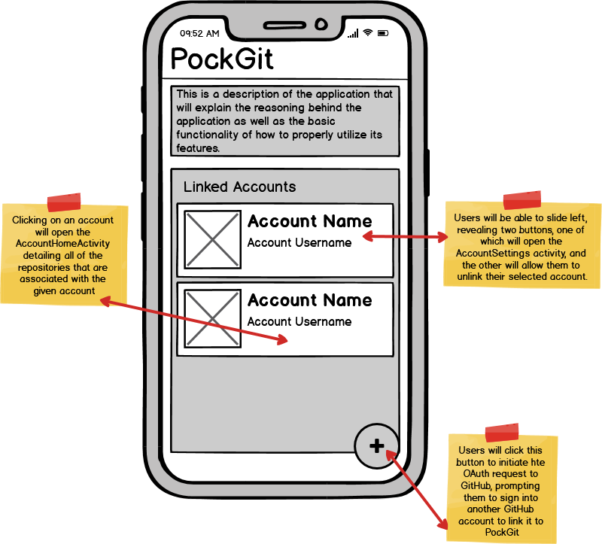

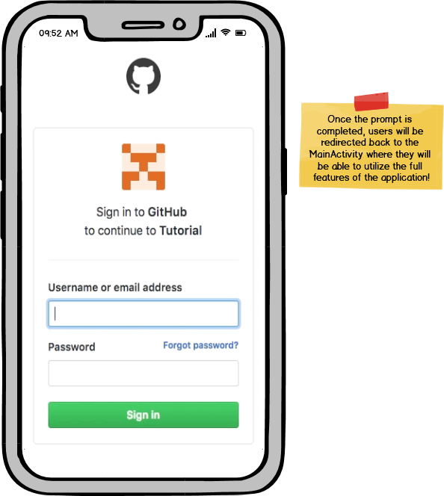

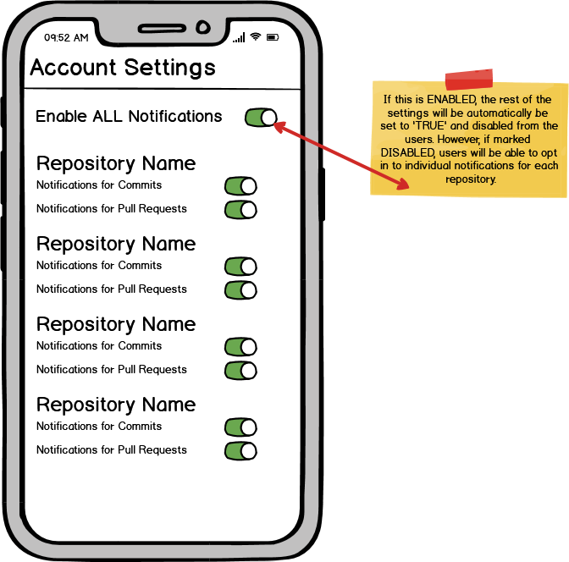

**Key Features #2**

* Purpose and Background
  + The second core features ties hand in hand with the previous, yet is just as important. Once users have authorized access to their GitHub account, PockGit will display not only a list of repositories that they are associated with, but will also allow users to search through all commits that have been made on a given repository. In an agile environment, the importance of having updated and relevant information at your fingertips cannot be understated, making this feature an absolute necessity.
* Workflow
  + In the AccountHomeActivity, users will be able to click on one of their repositories, which will open the RepositoryDetailsActivity containing all relevant information about the repository as well as a detailed history of all previous commits to said repository.
  + From here, users can scroll through the list of commits that have been made to the repository, or they will also have the option to search the list by entering a date range or keywords.
* Errors/Edge Cases
  + Similar to what was previously discussed on the last feature, a large portion of potential errors will come from a lack of internet or other network issues. If that is the case a well explained message will be displayed to the user detailing what has occurred.
* Mockups

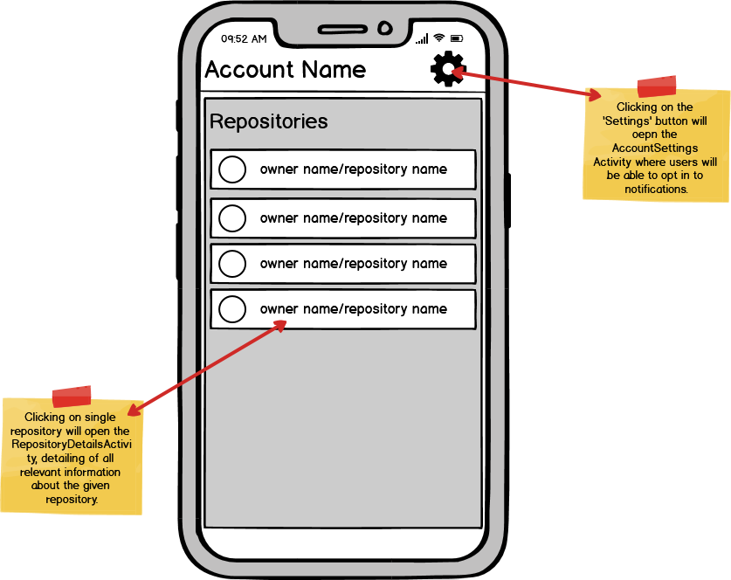

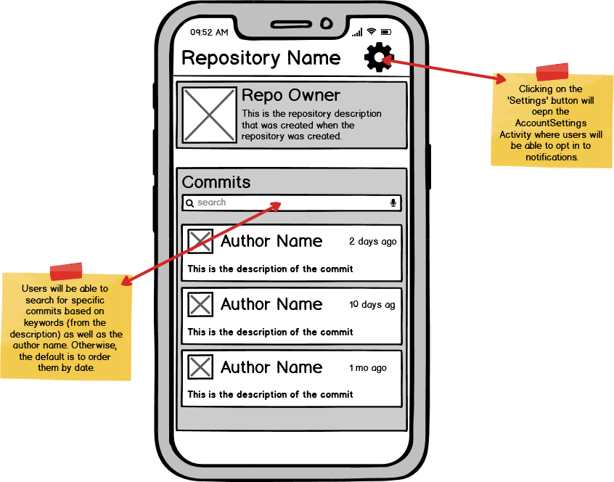

**Similar Applications**

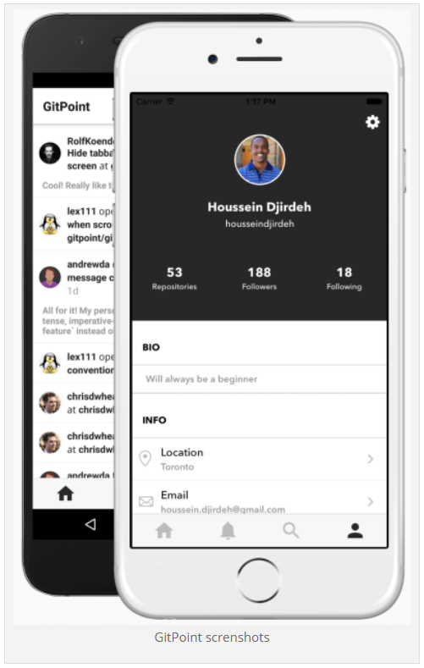 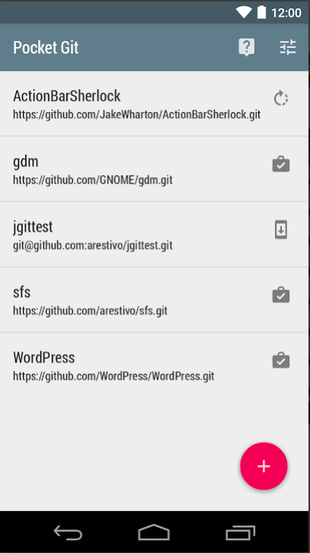

**Color Palette**

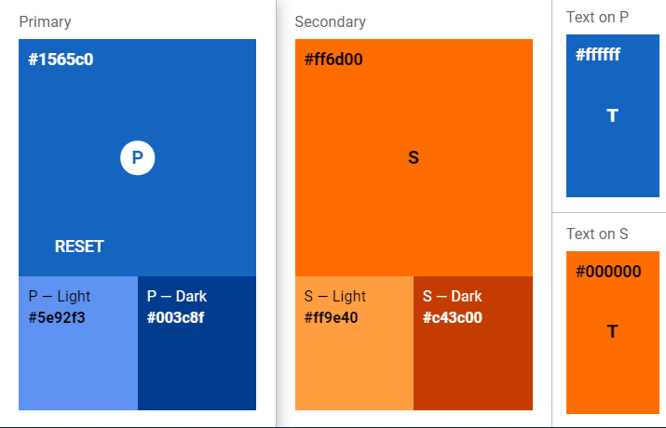

**Approval Signatures**

|  |
| --- |
|  |
| [Name], Student | |  | [Name], Instructor |